**AFRICA NAZARENE**

**UNIVERSIT Y**

**DIPLOMA INFORMATION TECHNOLOGY**

**ONLINE PEACE TAILORING SHOPPING STORE**

**BY**

**SYLVIA YVONNE ONSERIO**

**17S03ADIT018**

**SUPERVISOR**

**MR. AMBROSE NJERU**

**SEPTEMBER 2018**

# Contents

Contents 2

1. CHAPTER ONE 3

1.1 Introduction 3

1.2 Problem Statement 3

1.3 Smart Objectives 3

1.3.1Research Objectives 3

1.3.2 System development objectives 3

1.4 Scope of the project 4

1.5 Research Questions 4

1.6 Assumptions and Limitations 4

1.7 Justification 4

2. Literature review 5

2.1 Introduction 5

2.2 Overview of online shopping stores 5

2.3 Preview of existing system 6

2.3.1 Mimi Kenya 6

2.3.2 Jumia Online Stores Kenya 6

2.3.4 Mama Mike’s Online store. 6

2.4 Overall weakness of the visible in all the three stores 7

3. METHODLOGY 8

3.1 RESEARCH METHODOLOGY 8

3.2 SYSTEM DEVELOPMENT METHODOLOGY 8

3.2.1 Requirement Specifications 8

3.2.2 System analysis and design 9

3.2.3 System coding 9

3.2.4 System testing and debugging 10

3.2.5 System deployment and Maintenance 10

3.2.6 Resources required. 10

3.2.7 System development Timeline 11

References 12

# 1. CHAPTER ONE

## 1.1 Introduction

Online Peace Tailoring shopping store was developed for the smooth ordering and buying of any type of fashion design at affordable price in the city of Nairobi and other places one would want to order. My research enabled me recognize and define the problem in the current online stores. After an information gathering process from several online shopping stores, I saw that the business indeed needed one to create a system that would enable customers whether female or male when shopping online to be able to put their personal details online so as not encounter a problem in finding best design of any occasion and save time when one is being delivered. After a close analysis of samples collected during the problem definition stage, I found out that the buying and ordering of fashion design clothes in online Peace Tailoring is readily available in the city due to its affordability to many customers and owners due to it meeting human expectations .Online Peace Tailoring shopping store was developed to ensure that there is maximum efficiency of any type of design the customer wants .The e-commerce website will indeed help the Online Peace Tailoring shopping store and the staff members to manage and steer the business functionality and transactions to realize its maximum potential in addition to its competence in the Online shopping stores business field.

## 1.2 Problem Statement

In some current online shopping stores, they specialize on one gender to manage the store. This delays many especially to a customer who wants to shop for the family at the same time.

Unfortunately, there are bookings done online but the customer’s personal details such as Name, Location, Duration of hiring, his or her size and type of material to be used where it saves time and money for the customer and seller during delivery.

## 1.3 Smart Objectives

### 1.3.1Research Objectives

1. Research on online labor leasing services and existing platforms.

### 1.3.2 System development objectives

1. Creating a system that will enable users to login as either shoppers, Designers and transporters.
2. A system that will enable shoppers to connect to designers within a similar geographical so as to save on time and cost of services between both parties.
3. Creating a system that enables shoppers to evaluate the products and designers prior to paying for the services.
4. Designers should be notified once they have booked for the design of a shoppers clothing.

## 1.4 Scope of the project

This project will focus on helping the online Peace Tailoring shopping store to sell their designs online to everyone regardless of whether male or female by creating a system that would enable them put their personal details such as Name, Location, Duration of hiring, his or her size and type of material to be used because by doing so they will reduce time wastage by ordering them at the same time and when delivering no extra charges due it being return because of the size is large or small.

## 1.5 Research Questions

1. How to enable customers to be able to give their personal details online such as Name, Location, Duration of hiring, his or her size and type of material to be used so as to minimize the time wasted on looking for a design.
2. How customers and visitors can view for the designs they want online in any given time before they give an order

## 1.6 Assumptions and Limitations

Online Peace Tailoring clothing store assumes that:

1. Everybody has internet access.
2. Everybody has good computer and technology skills.
3. Everybody has a good communication device.

## 1.7 Justification

With the current technological advancement and explosion of the internet globally, Kenya is of the countries that is enjoying the benefits of such advancements with above 60% of its population having access to the internet and other technologies that seem to make the world a global village. This therefore means that at least 6 out of every 10 Kenyans have access to the internet services. This is further boosted with the mobile phone penetration with over 80% of the population having access to mobile phones and other computing devices. Having this knowledge in mind we can therefore observer that a web-based shopping would be a perfect fit as a technology to deploy our online store. This is due to the fact that website can be accessed across all devices and across all technologies used to deploy mobile services. This there means that whether an individual is on IOS, Android, Linux and Windows device or using a smartphone, tablet, desktop or laptop computer, the individual will still be able to gain access to the shopping services. (Anon., 2018)

# 2. Literature review

## 2.1 Introduction

This chapter aims at taking a look at the current online shopping that mainly focus on clothing as their main product. The problem statement highlighted in chapter on will be looked into in more detail with respect the existing stores selling cloths using the various online platforms available. The chapter will consider the factors affecting customers as they make their purchases from these stores. The various issues facing the online stores will be analyzed and be used to point out the various issues the online stores. The knowledge acquired from this chapter will then be used to form the basis of strength and uniqueness for the online stores that is to be developed in this project. This will also enable the business to have better operational model that will ensure a higher return on investment and within a short period of time.

## 2.2 Overview of online shopping stores

In today’s world the average adult is most an employee who spends a better part of his day at the work premises. This therefore leaves such an individual with very little time to carry out other personal activities such as shopping. Thanks to the evolution of technology and the rise of the internet, this individual is now able to carry out shopping for most of the daily items that they might need in their household from the comfort of their homes. This comes even more handy in the busy holiday season where the individual only is saved from the trouble of waiting in long queues and having to bother with the opening and closing of the stores since online stores are open 24 hours a day. Another interesting thing about online clothing stores is that the customer is able to find a huge variety of items from the same store, somethings that would have require them to move from shop to shop if they were shopping manually. In the next sub section, we will a look at the existing online stores in the country such Mimi Kenya, Jumia Kenya and Mama Mike’s Online store.

## 2.3 Preview of existing system

### 2.3.1 Mimi Kenya

Mimi online store’s offices are located in Nakumatt road, Kahawa Nairobi and First floor, Avenue House. Mimi influences the fashion Kenyan ladies take especially the middle class where the targeted average dresses is about 3000.Delivery is done well as long as you wait their delivery days. Presenter Julie Gichuru centered her business plan around the growing culture of online trade and commerce that is already fast developing where online offers increased accessibility to markets than a shop in a mall. It also has classy, sophisticated and trendy fashion for everyone especially Kenyan ladies. It is also one of the Kenyans leading selling of clothes through her dressing attracts and her general popularity. This effectively makes her store get return on investment within a short period of time where she gets ten compliments and dressing suggestions on her social media after every Sunday live. It’s getting down comes where Mimi starts settling on high cost of rental properties in Kenya means an online that customers would have to pay much more for venture for their merchandise and this may make ladies who are below middle not to shop there. Also when one is delivered a dress, she may find it is not of her size. (Anon., 2018)

### 2.3.2 Jumia Online Stores Kenya

Jumia offline stores are in Nairobi CBD Emperor Plaza, Kenyatta Avn. Opp. GPO. It is an open business-to-consumer platform enabling business to reach Africa’s vast and growing consumer market. It has established itself as the destination for quality, branded products, catering and to an increasingly sophisticated African consumer(s).Their growth is largely influenced by the professionalism and carrier growth of their employees which they have backed with test practices and effective knowledge transfer from across the globe. It also provides opportunities for staff to grow across different roles in the organizations. Their employees have access to a comprehensive health plan which includes, their spouse and children and competitive salary package. When shipping in Jumia shopping store, making payment means accepting delivery. Therefore, it is not possible to open products bearing manufacturers seal, reject and send them back with the same driver if the product is oversize or smaller .it can only be returned if you haven’t opened and allow the return policy. For the ones overseas or anyone who wants to return, one will incur an extra shipping fee of ksh.100 when returning. (Anon., 2018)

### 2.3.4 Mama Mike’s Online store.

Mama Mike is also another one of the upcoming online stores. It deals mostly with adult clothing hence narrowing down their target market to mostly adults between the ages of 30-50years. This is due to the fact they focus mostly focus in the urban ware franchise, which has managed to attracted the customers within that given age bracket. Just like Jumia and Mimi, the store has a lot of similarities when it comes to identifying a dress is and get it is a simple as just logging into the site and picking your dress and waiting for the delivery. (Anon., 2018)

## 2.4 Overall weakness of the visible in all the three stores

Despite the above-mentioned stores facilitating selling of clothing at the consumers comfort there are still a lot of issues that are still left without being catered for. This include:

1. Customers don’t get to specify their actual body measurements for the clothes that they intend to buy.
2. In the instance a customer gets a delivery with the wrong measurements, some shops have policies that make purchase returns almost impossible.
3. There is lack of personal touch between the customers and the designers(tailors) hence limiting customers to only taking the ready-made clothes with the only thing that they can customize being the body size.
4. Some stores focus on imports and hence the period between shopping and the receipt of an order being longer than expected due to all the importation protocols.
5. Due to imports and the need to have a wide market base the companies spend more in establishing their business and initial costs and hence they end up having attires that are too expensive for the average consumer who will then have no other option but to resolve to using the old shopping methods.
6. Some stores also lack originality by not bringing designers on board as they insist on being middle-men in the businesses.

# 3. METHODLOGY

## 3.1 RESEARCH METHODOLOGY

This is the manner in which the problems to be solved while creating a new system will be identified and solved. In this case the internet will be of great use in providing the information on the existing systems and the problems being faced by the existing.

This is the manner in which a problem to be solved through the creation of a new system will be identified and given a logical sequence of steps that will contribute towards the solving of the problem at hand. In our case the internet will serve a great purpose in identifying the existent systems and their shortcomings which will play also enable the creation of an enhanced system. In the instances where further clarity is needed the owners of the existing systems will be contacted for more information.

## 3.2 SYSTEM DEVELOPMENT METHODOLOGY

The system will be developed using the Waterfall Project Management model. The model will contain the following steps:

1. Requirement specifications
2. System analysis and design
3. System Implementation/coding
4. Testing and Debugging
5. Deployment and Maintenance

### 3.2.1 Requirement Specifications

**Functional requirements**

The system should be able to meet the following functional requirements:

1. The system should enable users to create accounts and be able to carry out their roles i.e. shoppers, Designers and transporters.
2. Designers should have the ability to also create their own account s and be able to display their merchandise.
3. The system should also enable the shoppers to also be able to get in contact with the designers so as to be able to get customized products.
4. The system should have a mechanism of communication between the shoppers and the designers.
5. The system should enable the shoppers to make payments for their service and also enable the payment of the designers and the transport facilitators upon the completion of each purchase.
6. The system should enable the client to view the list of available designers and their products.
7. The system should enable the shoppers to be able to keep track of their purchases while designers keep track of their sales.
8. The system should also have a mechanism of enhancing the navigational capabilities of the transport facilitators during the delivery of the purchased goods.

**Non-Functional Requirements**

The system should be able to meet the following non-functional requirements:

1. **Usability –** the system should have a user-friendly interface for ease of use.
2. **Security –** the system should be able to guarantee the safety of user data and security of each transaction.
3. **Reliability –** the system should be accessed all 24/7 with less technical requirements
4. **Flexibility –** the system should be accessible from any device regardless of the operating system and hardware architecture.
5. **Accuracy –** the system should be accurate in terms of data inputs and outputs for all users.

### 3.2.2 System analysis and design

The system will be broken down into two parts:

1. **The front end** – this will be the website which the users will be interacting with. It will be composed of several webpages based on the user’s activity in the system.
2. **The back end** – this will be the part of the system that will be made up of the system’s database and be responsible for carrying out data processing.

The design of the system in terms of data flow will be represented using data flow diagrams and entity relationship diagrams.

### 3.2.3 System coding

The implementation and coding of the system will be done using the following software:

1. WAMP Server – a software that enables the local hosting of the website during the development period.
2. Sublime Text – this is a advanced text editor with support for languages such a HTML, CSS, JavaScript, PHP, MySQL and many more.
3. Google Chrome browser – this will be the testing browser for the system.
4. Windows 10 operating system – the operating system upon which the system will be deployed and tested during development phase.

The following scripting languages will be used:

1. **HTML** and **CSS** – language for the front-end design of the system’s webpages
2. **JavaScript** – language for enhancing interactivity and data entry validation on the webpages.
3. **PHP** – the language for connecting the webpages to the database of the system.
4. **MySQL** – the language implementing the system’s database.

### 3.2.4 System testing and debugging

After completing the development of the system testing will be done in order to ensure that the system functions as expected. The testing will be done in the following terms:

1. **Unit testing** – This will involve testing each module in the system for any error during performance.
2. **Integration testing** – this will involve the testing of how different in the system work when combined to work on a given task in the system.
3. **Data validation and exception testing** – this will done by entering both correct and incorrect data input into the system so as to see how the different modules will process data even in exceptional situations.
4. **System testing** – when all the above stages of testing are completed the whole of the system will be tested before being deployed.

### 3.2.5 System deployment and Maintenance

After completion of the testing and debugging phase of the system development life cycle, the system will then be deployed to a few users for testing for a given period of time so as to get the overall response on the system from users. The feedback from the users will then be used to tweak the system further in order to fit the overall user liking.

### 3.2.6 Resources required.

The hardware resources required for the development of the system will include:

a. Desktop computer or laptop having 4 GB of RAM, 300 GB of storage space 1 GB graphics memory.

The software resources required for the development of the system will include:

1. Windows 10 operating system
2. Sublime Text 3 text editor
3. Google Chrome Browser
4. WAMP server software

### **3.2.7 System development Timeline**

|  |  |  |  |  |  |  |  |  |  |  |  |  |  |  |  |  |
| --- | --- | --- | --- | --- | --- | --- | --- | --- | --- | --- | --- | --- | --- | --- | --- | --- |
| **Task No** | **Task Name** | **Planned Hours** | **Planned Start Date** | **Planned End Date** | **March** | | |  | **April** | |  | | **may** | | | |
| 1 | Problem Definition | 5 | 13/03/2017 | 17/03/2017 |  |  |  |  |  |  |  |  |  |  |  |  |
| 2 | Requirement  Analysis | 2 | 18/03/2017 | 25/03/2017 |  |  |  |  |  |  |  |  |  |  |  |  |
| 3 | System design | 5 | 26/03/2017 | 8/04/2017 |  |  |  |  |  |  |  |  |  |  |  |  |
| 4 | System coding | 30 | 9/04/2017 | 30/04/2017 |  |  |  |  |  |  |  |  |  |  |  |  |
| 5 | Testing and debugging | 100 | 1/05/2017 | 7/05/2017 |  |  |  |  |  |  |  |  |  |  |  |  |
|  |
| 6 | Deployment and maintenance |  | 8/05/2017 | 14/05/2017 |  |  |  |  |  |  |  |  |  |  |  |  |
| 7 | System documentation |  | 15/05/2017 | 21/05/2017 |  |  |  |  |  |  |  |  |  |  |  |  |

# System design

## Use case diagram

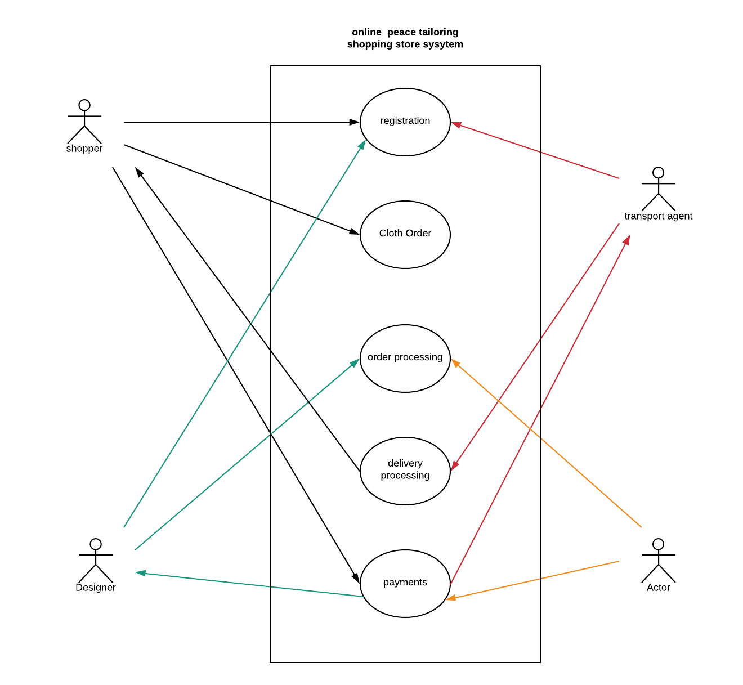

## Context diagram

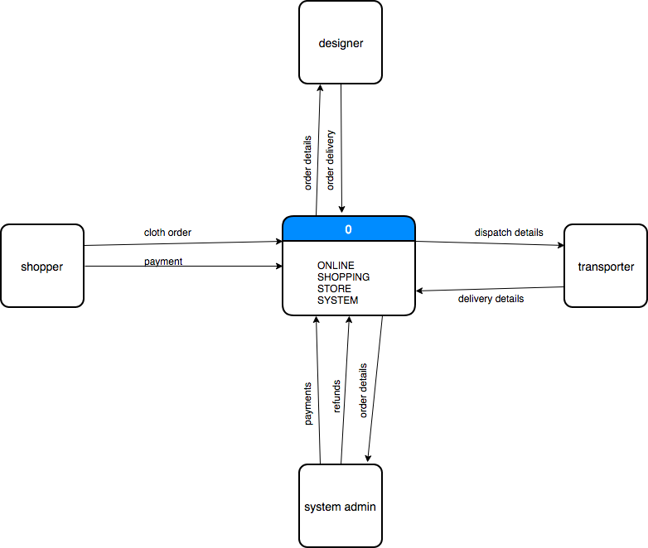

## Level 0 Data Flow Diagram

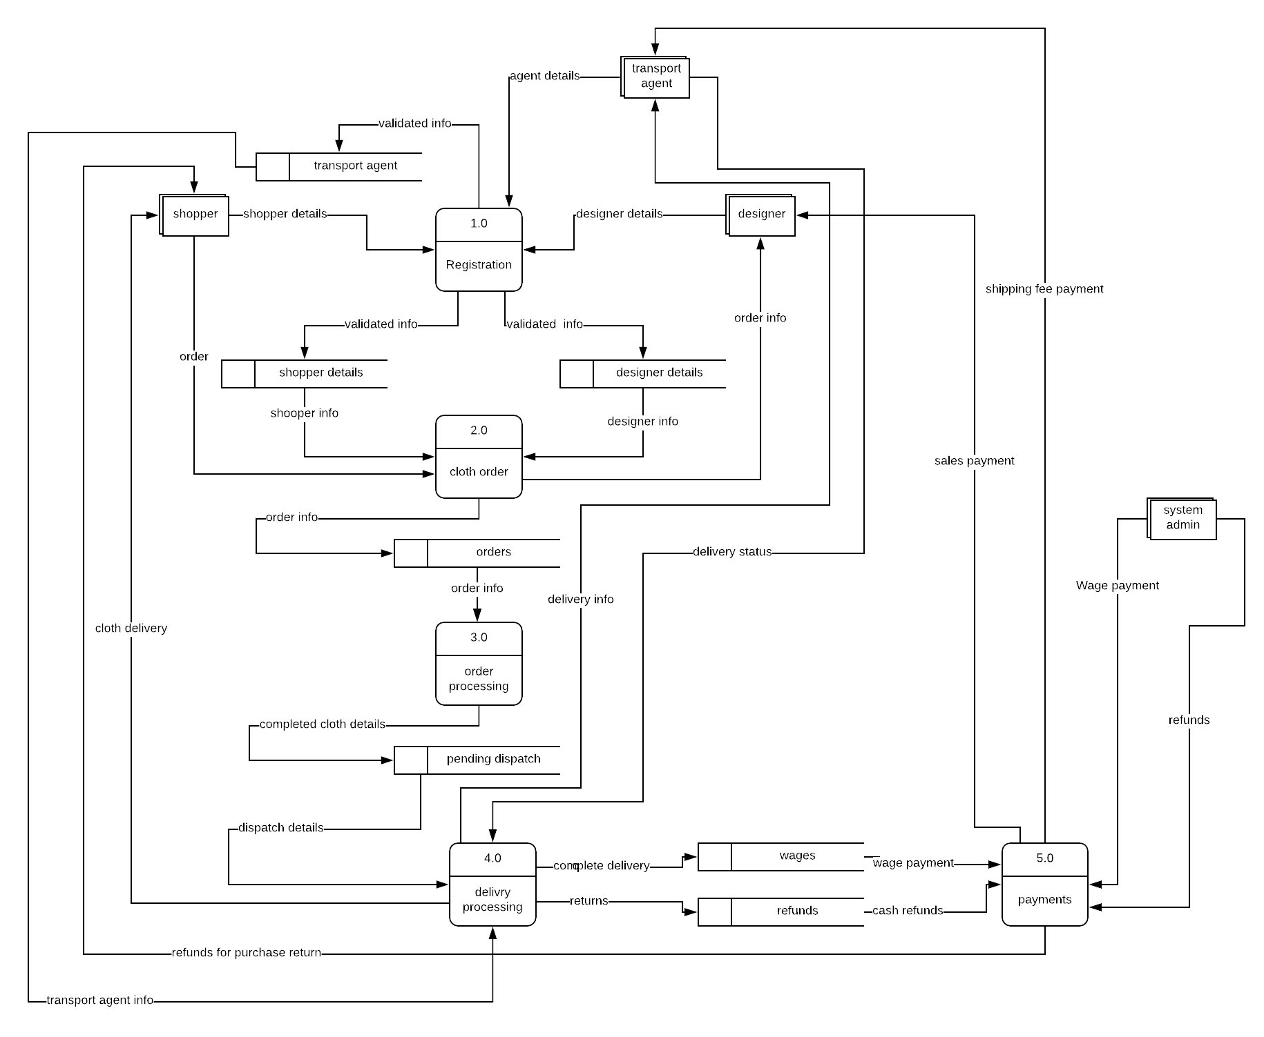

## Level 1 dfd

# References

Anon., 2018. *How many Internet users are in Kenya?.* [Online]   
Available at: https://www.businessdailyafrica.com/corporate/tech/How-many-Internet-users-are-in-Kenya/4258474-4259072-htn83lz/index.html

Anon., 2018. *Jumia.* [Online]   
Available at: www.jumia.co.ke

Anon., 2018. *Mama Mike's online shop.* [Online]   
Available at: www.mamamike.co.ke

Anon., 2018. *Mimi Kenya.* [Online]   
Available at: 1.1.1 www.mimi.co.ke

Mannic, 2018. *AI.* [Online]   
Available at: http://www.aiai.ed.ac.uk/links/cbr.html